I put some images below so you can see how it works.

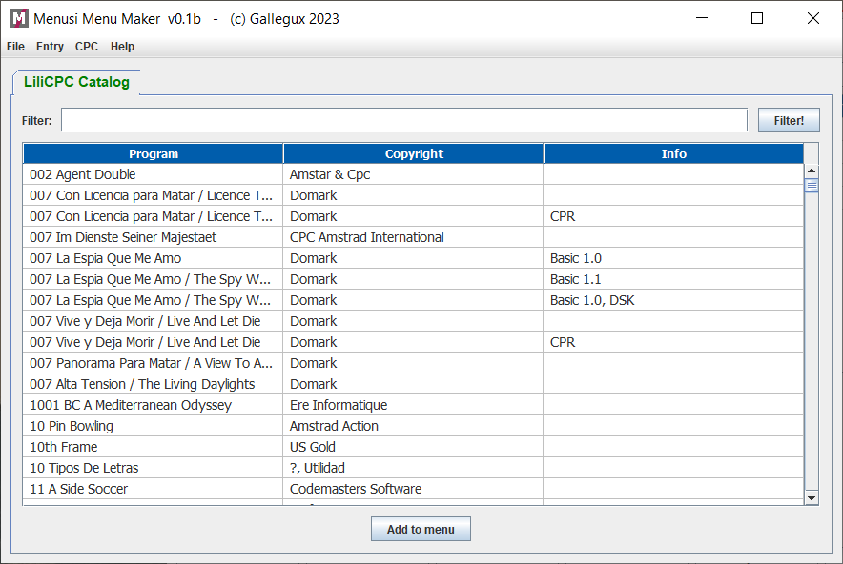
Initial screen. One tab with all LiliCPC programas

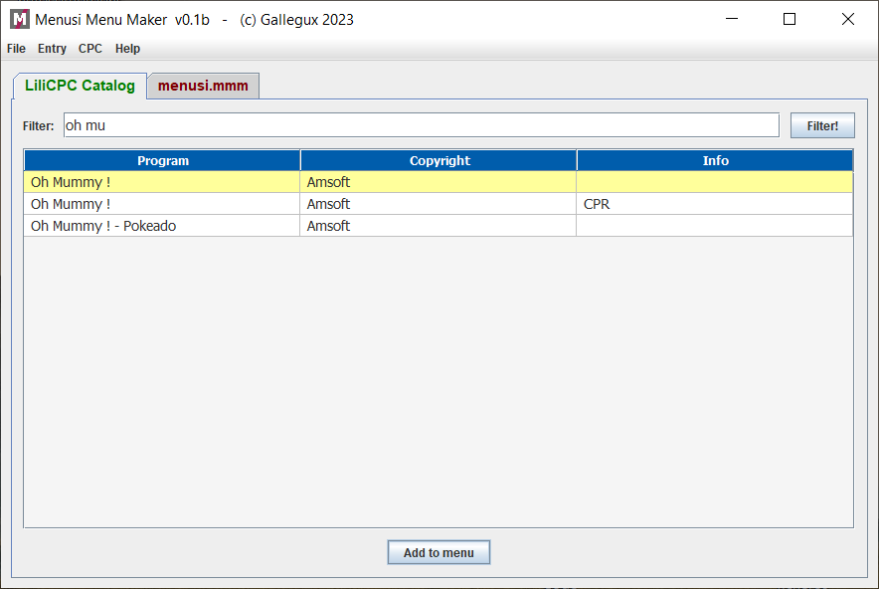
Searching "Oh mummy" and adding it to last open menu tab (in color red)

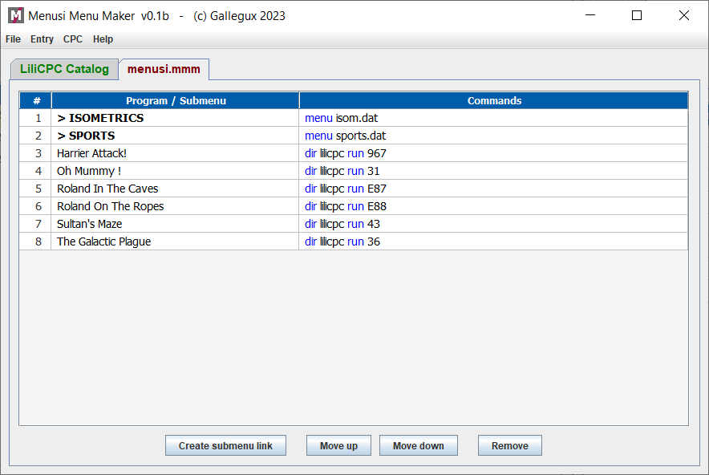
The main menu (menusi.mmm). It must be called MENUSI.DAT in Amstrad CPC.

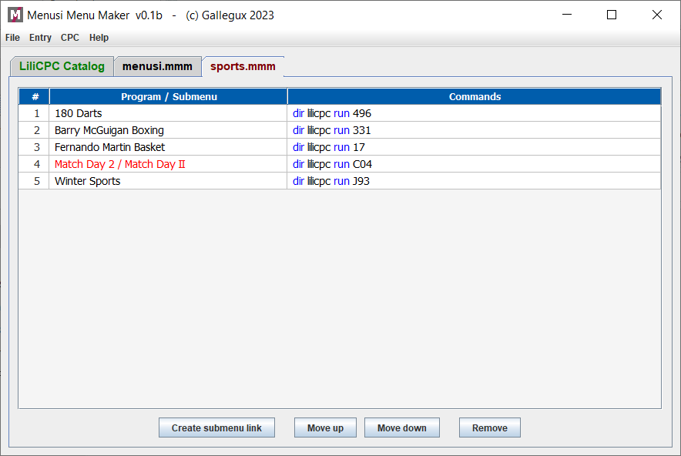
And the SPORTS menu. The max length for names is 24, so "Match Day II” appears in red. You had to rename it.

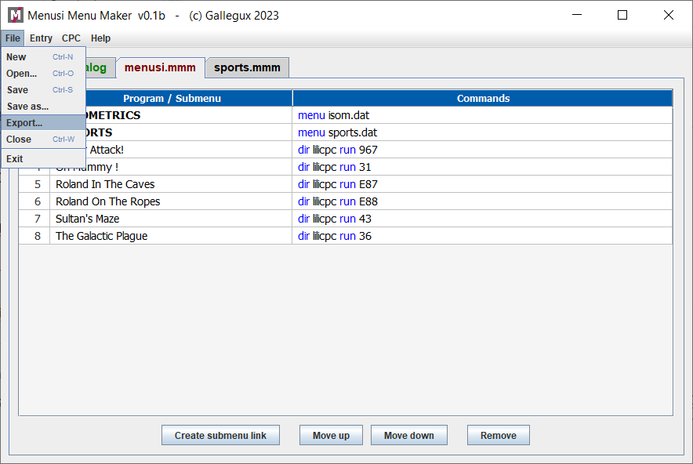
Exporting the menu to Menusi format, it creates the MENUSI.DAT file for Amstrad CPC.

To save menusi programs to a pendrive or SD use the CPC menu.
On Amstrad CPC, after launching menusi, menus appers like that:

